October 31, 2024

1.) Technology: The consensus drawback of using Hydrogen for energy storage is lack of efficiency. From an upfront capex perspective, I assume this is offset by decreased costs in scaling storage capacity, especially for larger storage use cases. I'd like to better understand the core technology you are developing, particularly as it relates to efficiency gains. The deck is clear on reducing the cost for the system.
For a deeper dive on the technology here is a link to our Technical Engineer White Paper if you haven’t seen it already.
Essentially it works by using the same membrane stack to either convert water + electricity into hydrogen or convert hydrogen back to electricity, depending which direction the protons are flowing. This is enabled by our critical innovation, a conducting polymer coating of the membrane which addresses the fundamental barrier that has prevented HTPEM technology from being commercially viable for electrolysis – degradation. This normally happens because the main membrane component, phosphoric acid, leeches when it comes into contact with water. Our coating prevents that contact while still allowing the proton exchange, extending the lifespan to 40,000+ hours of use. This, in combination with the efficiency gains from the high temperature of the system, gives us a starting point of 40% round-trip efficiency for the hydrogen component (including compression, etc.) – which is already equivalent to best-in-class LTPEM technology. The efficiency will increase as we develop new catalysts that are efficient in both electrolyzer and fuel cell modes (most catalysts used today are good at one or the other).
However, the round-trip efficiency of the HyWatts energy storage system, which combines long-duration hydrogen storage with short-term Li-battery storage, is much higher. Hydrogen storage covers power needs at low production from the solar energy source (‘rainy days’). The Li battery cycles almost every day, storing energy for peak shaving. That yields an overall RTE of >87% for the HyWatts system.
Given that the intention with long-duration storage is not arbitrage and that the system uses excess energy, as you’ve hinted at in your question - round-trip efficiency (RTE) is not the right metric to focus on. Our customers care about cost and the fact that we can deliver lower $/kWh & CAPEX versus other solutions, with the added benefit of low-cost green hydrogen.

2.) Initial Go-To-Market: I'm skeptical about the initial market in non-grid tied EV-charging. We have experience with EV-charging both as a customer and as an investor, and the persistent issue with EV-chargers is low utilization rates.
While our system is very well suited for fully grid independent systems, we are actually seeing greater uptake for partially grid-connected use cases where the customer is able to get some energy from the grid but not nearly enough to meet their needs. In fact, it is quite possible that the partially connected use cases will be the largest area of demand.
As far as the question of EV utilization rates, we are aware of the potential challenge. We have a few approaches to mitigating the risk:
- Expand the project portfolio outside of EV-charging – microgrids for communities, data centers, & warehouses.
- To activate the collaboration with dealers of EV-commercial vehicles (a turnkey solution – you buy 4 trucks, get the charging infrastructure for them from HyWatts)
How does the financial math work for a potential buyer for this use case, and how much of a subsidy are you assuming?
The most exciting thing is that our product gives attractive rates without subsidies. Moreover, we give our customers an option to make a dual-fuel station to serve battery- or hydrogen-electric vehicles (again, that will increase the utilization rate of the customer business). This dual-optionality allows our customers to claim increased subsidies (they can combine funding for EV-charging and Hydrogen vehicles). With this approach, customers can get up to 90% compensation on their CAPEX and increase the chances of being awarded because of HyWatts. As a result, they are ready to take the startup risk of working with us, and we assume to get enough funding for the development of the product.
I also share with you the unit economics of the product - LINK. We can go through the details during the call tomorrow.
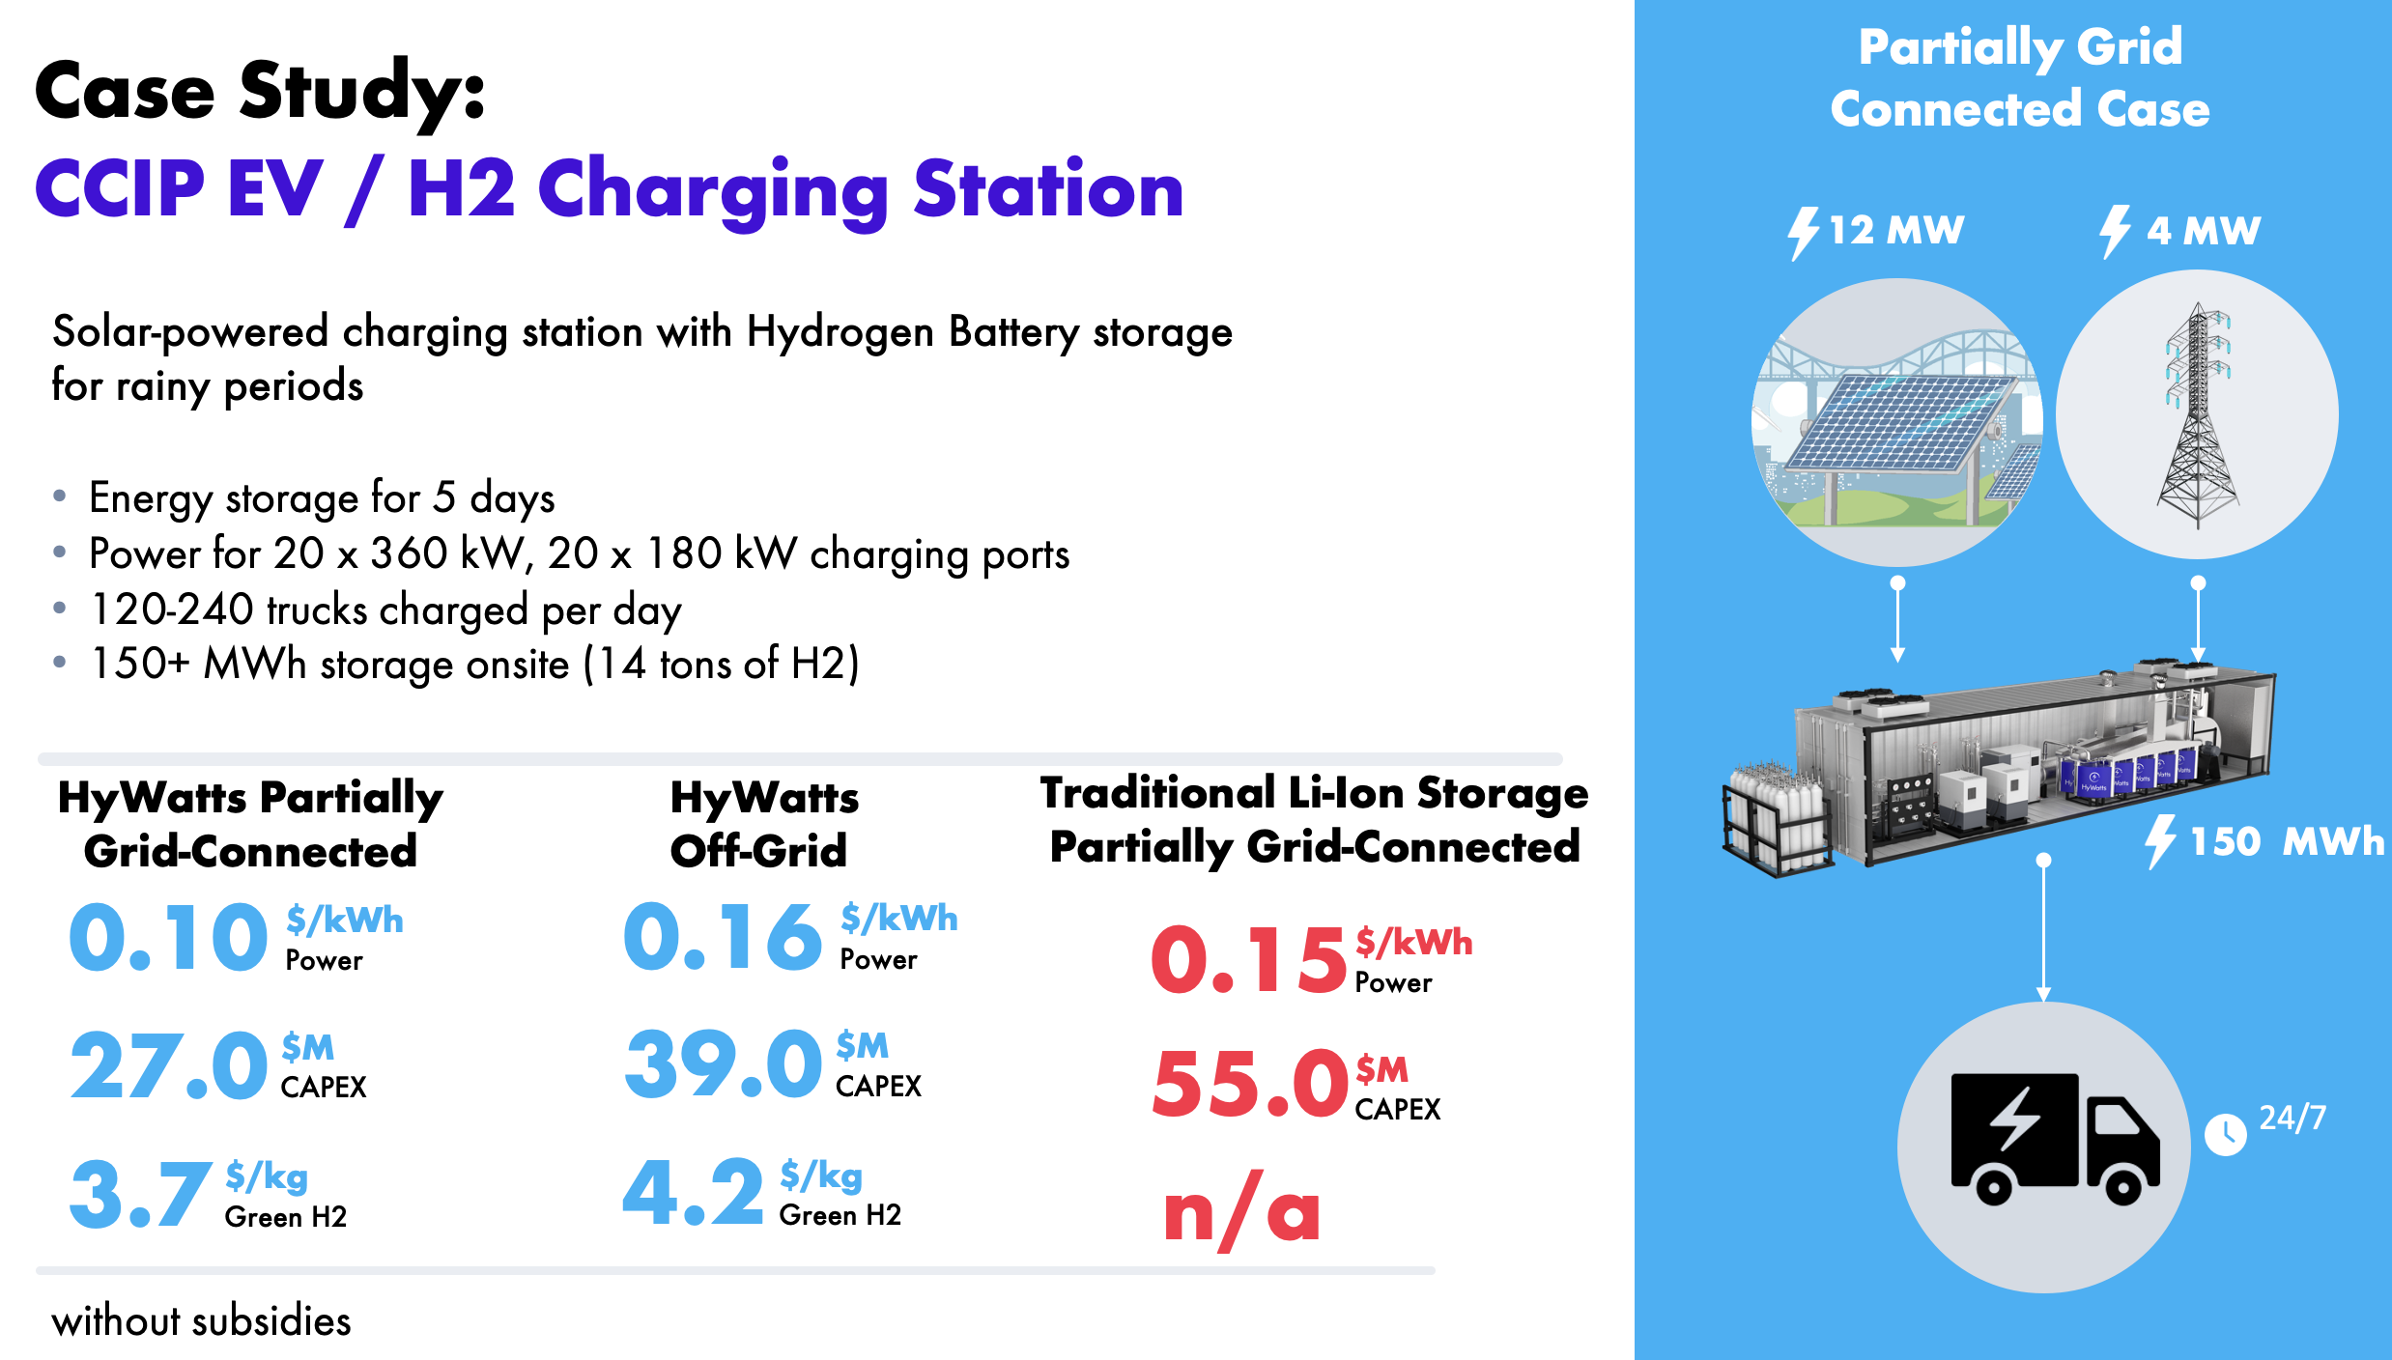
Also, what is the major problem you are solving? Is it long-duration storage, storage capacity, or both?
We are addressing both long-duration storage and storage capacity. Our system is designed to provide reliable renewable energy for multiple days, unlike battery-based systems, which are typically limited to shorter durations. We achieve this by generating hydrogen on-site, storing it in tanks, and converting it back to electricity as needed. This approach allows us to scale cost-effectively by simply adding more storage canisters, making it suitable for different applications like EV-charging, data centers and utility.

3.) Fundraising Strategy: I'd love to hear your thoughts on your future fundraising strategy. Given the timelines you've outlined, there's a realistic scenario that you will be back in market with a fundraise with some deployments but less meaningful financial traction. Is the story going to be centered around technology development in that case? And if that's the case, what are the KPIs you are tracking for the next round?
Let me share with you the path to commercialization with the funding required estimate - LINK. You may find the technological KPIs we are targeting.
Not only the technology development (but in general, yes, we are the hardware company and have to develop the technology and product that brings benefits to the market and our customers), we are also focusing on business development and serving different market segments to understand the market needs and risks. That helps us adjust the product and strategy based on this knowledge and environment. We are developing a platform solution that can be deployed in different market segments. For us, the business is first! It means that we don’t develop the product first and then think about commercialization. Exactly the other way around.
Also, I will be happy to go through the fin model during our call.

4.) LOIs: This is of a piece with topics 2 and 3, but I'd love to dig into your existing LOIs and understand the confidence level and timing for LOIs that represent the markets you are most excited about.
I share with you the folder with LOI, contracts, commercial pipeline - LINK

