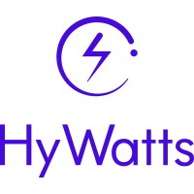 | Company: HyWatts, www.hywatts.com  Market: Renewable Energy  Product: Power-Plant-in-a-Box™  Notable Investors: Techstars LA, BuildTech VC, Aloniq, Climate Capital
Company Highlights:

- Signed seven letters of intent (LOIs) and successfully converted two into initial commercial feasibility studies as it aims to deploy a system MVP in December 2024
- HyWatts’ co-founder and CEO, Alex Ivanenko, previously sold hydrogen fuel cell company HyPoint to ZeroAvia for $100 million in September 2022
- In July 2024, HyWatts was one of 17 clean hydrogen and fuel cell projects selected to receive part of $3.4 million in funding from the Department of Energy (DOE) to develop a novel water electrolyzer
- Signed partnership agreements with notable organizations such as BASF, Sunbo Unitech, and the Clean Energy Institute at the University of California Irvine

WHY IT’S INTERESTING

The energy sector is at a crucial turning point, driven by the need for sustainable innovation. Global energy demand is projected to increase more than 100% by 2050, yet over 80% of this energy still comes from fossil fuels. With the increasing demand for energy use in electric vehicles (EVs), data centers, and more, hydrogen is attracting significant investment from both governments and the private sector as a clean alternative fuel. As a result, the green hydrogen market is projected to grow at a 61.1% compound annual growth rate (CAGR) through 2030. HyWatts is developing a Power-Plant-in-a-Box™, which combines solar energy production and hydrogen storage using a high-temperature proton-exchanged membrane (HTPEM) Reversible Fuel Cell. This system aims to enhance efficiency, cut costs, and provide a reliable, renewable power solution that stabilizes supply and reduces environmental impact.

Founded in 2023, the company is led by a team with an impressive track record separate from HyWatts, including an $80 million exit of a company with similar technology, 16 patents, and $180 million of capital previously raised. According to HyWatts, its innovative technology has the potential to reduce capital expenditures (CapEx) by more than two times compared to existing hydrogen technology and by over five times compared to lithium-ion battery technology. As of July 2024, the company has six signed LOIs, two of which (CCIP and L-Charge) have already been converted into feasibility studies. With plans to deploy its minimal viable product (MVP), a Power-Plant-in-a-Box™ system in December 2024, and test its first five-kilowatt (kW) stack prototype in January 2025, HyWatts is aiming to make its mark on the future of renewable energy.



Companies that have signed LOIs with HyWatts

EXECUTIVE SNAPSHOT

HyWatts is developing zero-emission hydrogen fuel cell solutions with potential applications in a variety of use cases including zero-emission vehicle (ZEV) charging stations, data centers, and more. Notable highlights from the company include:

- Small Business Innovation Research (SBIR) Grants: HyWatts received part of $3.4 million in DOE funding in July 2024 for developing a water electrolyzer and completed Phase 1 of an SBIR grant with Piasecki Aircraft for the Navy and Marine Corps in May 2024
- Experienced Team: Founding team boasts a successful $80 million company exit, and separately, 16 patents and over $180 million in venture funding previously raised
- Commercial Traction: HyWatts has signed seven LOIs, two of which (with CCIP and L-Charge) have been converted into commercial feasibility studies
- IP Protection: Filed two patents aimed at protecting its hydrogen and reversible fuel cell technologies
- Technology Development: Achieved several milestones as it aims to deploy its first system MVP in December 2024 and first 5-kW prototype test in January 2025

COMPANY SUMMARY

Opportunity

The demand for electricity is rapidly increasing due to the widespread adoption of artificial intelligence (AI), electric vehicles (EVs), and other energy-intensive technologies. Data centers and AI are projected to account for up to 4% of global power demand by 2030, significantly impacting overall energy consumption. Furthermore, the global EV fleet, which consumed about 130 terawatt hours (TWh) of electricity in 2023, is expected to rise dramatically, potentially representing 6-8% of total electricity demand by 2035. This surge in demand exposes the limitations of the current power grid, necessitating upgrades estimated to cost around $2.5 trillion to accommodate future energy needs.

HyWatts aims to tackle these challenges by developing the Power-Plant-in-a-Box™, an innovative solution that strives to integrate on-site solar energy production with hydrogen-based energy storage. Unlike traditional hydrogen methods, the system plans to utilize a single HTPEM Reversible Fuel Cell to efficiently convert solar energy into hydrogen and back into electricity, thus enhancing overall efficiency and reducing costs. By generating, storing, and converting energy on-site, HyWatts aims to offer a reliable, renewable, and cost-effective power solution. This technology not only has the potential to stabilize the power supply but also reduce environmental impact, making it ideal for applications such as EV charging stations.

Product

Power-Plant-in-a-Box™

HyWatts is developing a Power-Plant-in-a-Box™ that aims to combine on-site solar energy production with an advanced hydrogen-based energy storage system. The system seeks to produce hydrogen using solar power, store it in tanks, and utilize it as an energy storage medium. Traditional hydrogen technologies require separate electrolyzers (which convert electrical energy into molecules with high potential energy densities) and fuel cells (electrochemical cells that convert chemical energy into electricity) to turn electricity into hydrogen and then back into electricity. Unlike these traditional technologies, HyWatts plans to integrate these functions into a single HTPEM Reversible Fuel Cell, made possible by its novel conducting polymer. The technology’s objective is to streamline the electrochemical process, potentially enhancing efficiency, reducing costs, and providing a reliable, sustainable energy solution with minimal environmental impact.
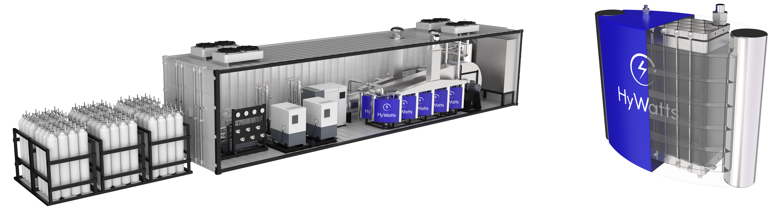HyWatts’ Power-Plant-in-a-Box™ and Reversible Fuel Cell Renderings

How It Works

The Power-Plant-in-a-Box™ is intended to work as follows:

- Renewable Power Generation: Solar panels generate renewable power on-site
- Hydrogen Conversion: Excess renewable power is converted to hydrogen (H2) and stored in on-site tanks
- Electricity on Demand: The stored hydrogen is converted back to electricity using a single HTPEM Reversible Fuel Cell
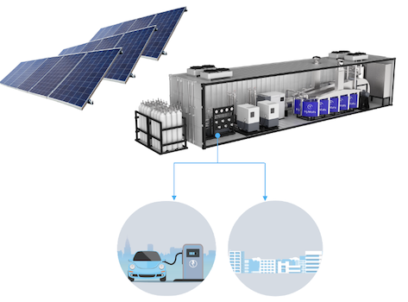
Technology Development Status

System MVP: HyWatts has begun developing its system MVP for the Power-Plant-in-a-Box™. The system MVP, which is scheduled to begin assembly in August 2024, intends to consist of an 8.5’ width x 16’ length enclosed bumper pull trailer equipped with roof-mounted solar panels. The inside of the trailer plans to contain system-critical elements such as an H2 storage tank and booster as well as a fuel cell cabinet, electrolyzer rack, and air compressor, among others. To date, the company has completed the following milestones as it aims to deploy the system MVP by December 2024:

- May 2024: Long lead time items ordered and system diagram, 3D design complete
- April 2024: Concept design complete and major components selected

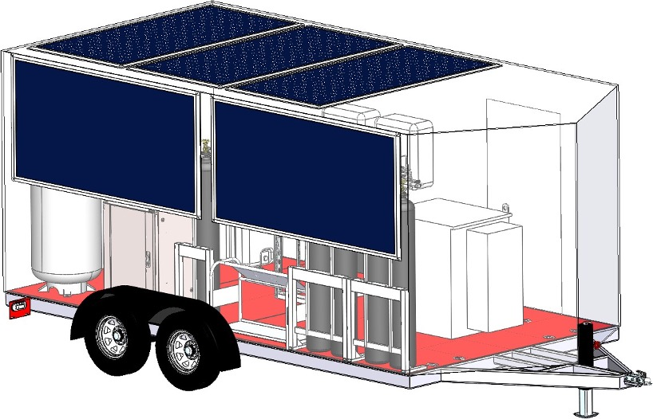
HTPEM Fuel Cell Research: HyWatts has also started research and development (R&D) of its HTPEM Fuel Cell, which aims to combine an electrolyzer and fuel cell into a single component. To date, the company has completed several milestones as it aims to deploy its first 5-kilowatt (kW) prototype test in December 2024, including:

- June 2024: Preliminary design approval complete
- May 2024: Bipolar plate prototype fabricated and membrane electrode assembly (MEA) prototype on order
- May 2024: Stack requirements and conceptual design complete

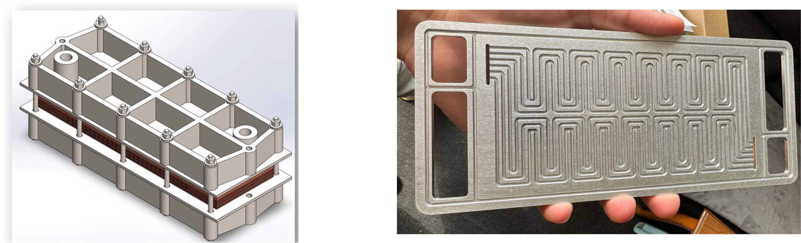

Intellectual Property (IP)

Aiming to protect its technology, HyWatts has filed two patents for the design of its HTPEM Reversible Fuel Cell System as well as the HTPEM MEA. As the company’s technology continues to develop, it anticipates averaging at least one additional patent per year to help further protect its innovations.

Use of Proceeds

HyWatts plans to allocate the majority of proceeds from this round to finalize the development of its first 5kW stack prototype and system MVP, along with providing for general working capital needs.

Product Roadmap and Go-to-Market (GTM) Strategy

Product Roadmap

The company plans to begin smaller pilot systems in late 2024/early 2025 before moving into full-scale commercialized systems in 2026. As it aims to reach commercialization, HyWatts has outlined the following technology roadmap:

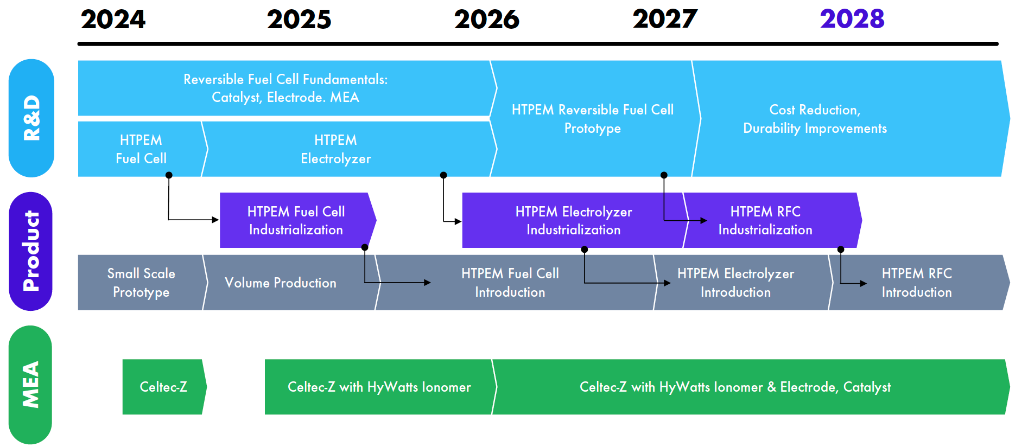

GTM Strategy

After completing initial customer discovery, Phase 1 of HyWatts’ GTM strategy is to target ZEV charging stations in rural areas, focusing specifically on existing truck stops as well as new stations. In Phase 2, the company plans to expand to data centers, warehouses, and community microgrids by 2028. Lastly, Phase 3 of the company’s GTM strategy aims to expand into utility scale storage by 2030 and beyond.

Business Model

HyWatts plans to implement an Energy-as-a-Service business model, offering customers a 25-year power purchase agreement (PPA) with no upfront costs. The price per kWh is expected to vary by project, with the company estimating charges to range between $0.11 - $0.16 per kWh. This model will aim to deliver low-cost energy by partnering with financing entities to leverage available incentives and rebates, minimizing expenses for customers.

USER TRACTION

Commercial Traction
Since inception in 2023, HyWatts has secured six letters of intent (LOIs) with companies including Cal City Industrial Park (CCIP), L-Charge, ClearWay, Manston Airport, Energy Securities Inc./Mighty Buildings, and Palari.

As of July 2024, the company has successfully converted two of these LOIs, with CCIP and L-Charge, into initial commercial feasibility studies. Details of the studies can be seen below.


Initiated in June 2024, the feasibility study with CCIP involves developing a conceptual design and system configuration for EV charging stations. The study will focus on outlining system performance, components, footprint, and cost analysis. The proposed configuration includes 20 x 180kW and 20 x 360kW fast DC chargers for EVs, capable of being fully off-grid or partially grid-connected, with a required power level of 11MW.


Initiated in June 2024, the feasibility study with L-Charge involves developing a conceptual design and system configuration for a mobile EV charging station. The study focuses on system performance, components, footprint, and cost analysis. The proposed configuration includes a fuel cell rated at 75kW, a battery buffer system with over 7kWh capacity, and hydrogen storage with a capacity of at least 85kg of H2. The system also aims to achieve a total weight of 6,000 lbs. or less, integrating advanced control algorithms and a control area network (CAN) bus interface for efficient operation.
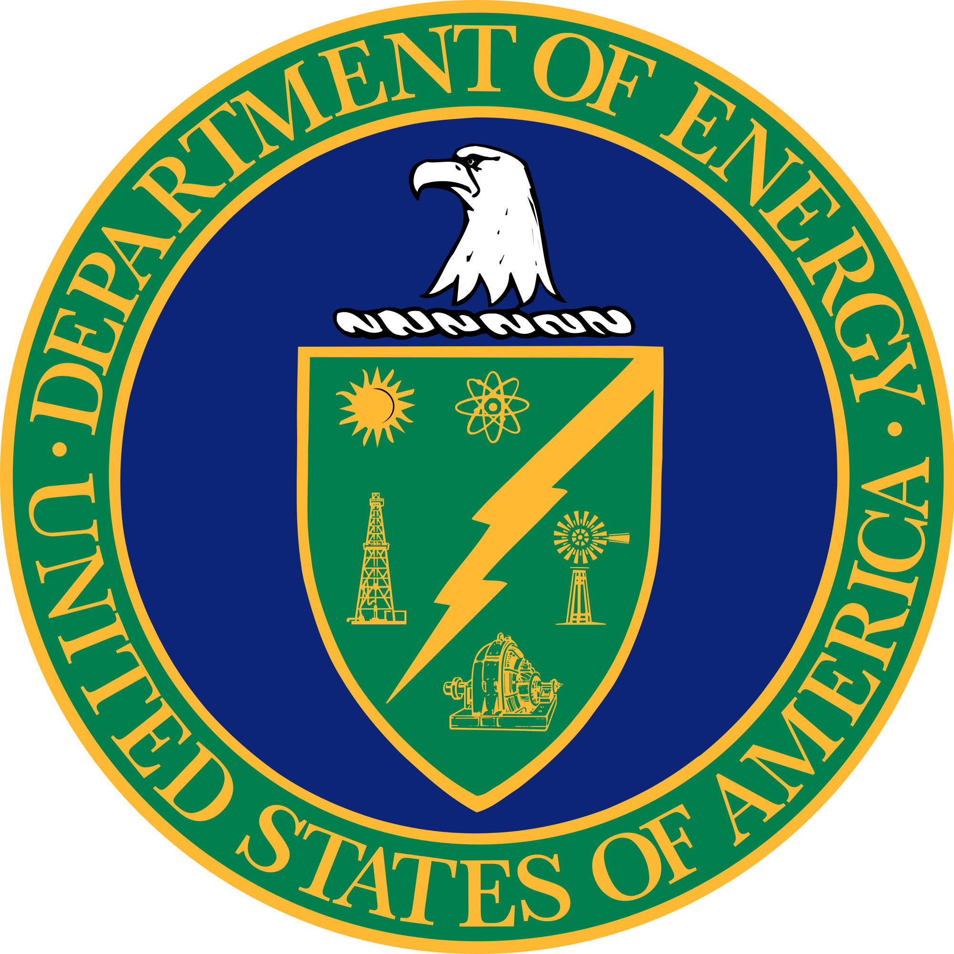
SBIR Grants

In July 2024, HyWatts was one of the 17 projects selected for funding by the U.S. DOE as part of its $52 million SBIR and Small Business Technology Transfer (STTR) awards. HyWatts will receive part of the $3.4 million allocated for hydrogen and fuel cell projects. Its project will focus on developing a novel water electrolyzer for hydrogen production using an intermediate temperature membrane.


In collaboration with Piasecki Aircraft Corporation in May 2024, HyWatts completed Phase 1 of the Marine Corps Systems Command (MCSC) SBIR and STTR grant program. The Phase 1 study focused on developing an integrated reversible fuel cell system using HTPEM fuel cells with a hydrogen electrolyzer for the Navy and Marine Corps. The system aims to produce power from hydrogen or generate hydrogen fuel from excess solar power, addressing power, weight, and fuel efficiency issues in Expeditionary Advanced Bases (EAB). The system proved to be a more reliable and lighter alternative to traditional solar battery setups, ensuring continuous power and water generation for extended operations. The two companies have jointly filed a Phase II application and are expecting results in August 2024.

Partnerships and Collaborations


In July 2024, HyWatts and the University of California, Irvine's Center for Energy Innovation (UCI CEI) partnered to enhance hydrogen-based energy systems. This partnership focuses on collaborative research in electrolysis, fuel cells, and hydrogen storage systems, aiming to develop advanced components for hydrogen fuel cells. The collaboration also includes joint efforts to secure grant funding, establish product specifications, and improve high-volume manufacturing methods and testing protocols.

In December 2023, HyWatts partnered with German chemical producer BASF and its affiliates to potentially enhance renewable energy products using its high-temperature proton exchange membrane, Celtec-Z. This collaboration intends to focus on developing improved membranes, catalysts, and electrolyte management solutions, as well as implementing high-volume manufacturing methods and new testing protocols. It also features joint marketing activities such as announcing R&D efforts and using company logos and brands in promotional materials.


In October 2023, HyWatts partnered with hydrogen generation and production company Sunbo Unitech to explore synergies between its reversible fuel cell system and Sunbo’s advanced PEM water electrolysis systems for green hydrogen production. This collaboration aims to integrate Sunbo Unitech's hydrogen electrolyzer systems into HyWatts' product designs and increase the market reach and production volumes of both companies' technologies. Additionally, HyWatts may serve as an exclusive distributor for Sunbo Unitech's products in selected countries.

Other notable organizations in HyWatts’ partner network include:

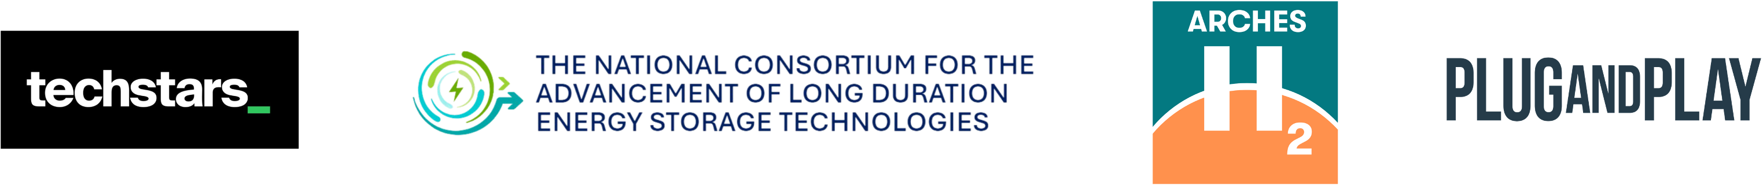

INDUSTRY AND MARKET ANALYSIS

Renewable Energy

The global renewable energy market, including solar, wind, hydropower, and bioenergy, was valued at $1.21 trillion in 2023 and is projected to reach $3.60 trillion by 2030, growing at a CAGR of 17.2% from 2024 to 2030. This growth is primarily driven by government regulations aimed at reducing greenhouse gas emissions and increasing investments in alternative energy sources. Moreover, the transition towards low-carbon fuels and stringent environmental regulations in developed countries are significant contributors to this trend. According to Deloitte, the renewable energy industry is poised for significant growth in 2024, driven by historic investments and increasing demand for clean energy. Despite challenges like rising costs and permitting delays, the renewable energy sector is expected to continue its expansion with advancements in various technologies and regulatory support. Key trends shaping the industry in 2024 include:

- Regulatory Boosts: The implementation of the Inflation Reduction Act (IRA) and Infrastructure Investment and Jobs Act (IIJA) is set to drive investments in solar, storage, and hydrogen projects.
- Supply Chain Reshoring: Establishing domestic manufacturing plants for upstream components to reduce import dependence and enhance resilience.
- Workforce Reskilling: Expanding and retraining workers to support the growing renewable energy infrastructure, with a focus on emerging technologies and generative AI.
- Renewable Resilience: Increasing the reliability of renewables, particularly during extreme weather events when traditional energy sources may fail.
- Emerging Technologies: Geothermal energy and renewable natural gas (RNG) are expected to play more significant roles, offering synergies with existing renewable energy sources.

IIJA/IRA Boosted Solar & Storage, Teed up Hydrogen Takeoff, and was Beset by Wind Brakes
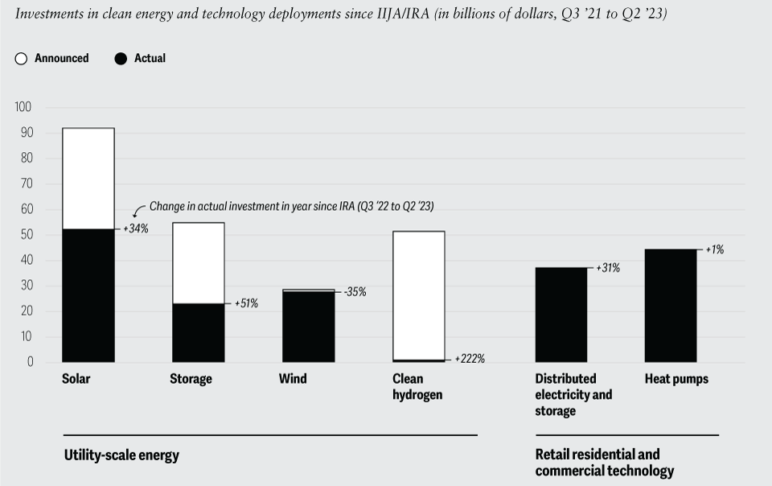
Source: Deloitte, December 2023

Green Hydrogen Energy & Storage

Green hydrogen is a type of hydrogen that is produced using renewable energy sources, such as solar or wind power, to split water into hydrogen and oxygen through electrolysis. The green hydrogen energy and hydrogen storage markets are poised for significant growth, driven by technological advancements and supportive government policies. According to Markets and Markets, the global green hydrogen market is projected to grow from $1.1 billion in 2023 to $30.6 billion by 2030, exhibiting a CAGR of 61.1%. This growth is fueled by the decreasing costs of renewable energy and electrolyzers, making green hydrogen a viable alternative for decarbonizing industries such as transportation, power generation, and heating.

Simultaneously, the hydrogen storage market is expected to expand, with its 2023 market size of $11.4 billion projected to reach $196.8 billion by 2028. The increasing adoption of hydrogen as a clean energy source necessitates efficient storage solutions. Compressed hydrogen, liquefied hydrogen, and material-based storage technologies are being developed to meet the growing demand. These storage solutions are crucial for applications in fuel cell vehicles, grid services, and industrial processes.

According to McKinsey, green hydrogen production is expected to dominate the global supply mix by 2050, accounting for 50-65% of the market due to cost reductions in renewables and electrolyzers. Blue hydrogen, produced using natural gas with carbon capture and storage, is projected to make up 20-35% of the supply, concentrated in regions with cost-competitive natural gas and carbon capture, utilization, and storage (CCUS) capabilities, such as the Middle East and North America. In contrast, green hydrogen production will be higher in regions with abundant renewable resources like Australia and Iberia. The global shift towards green hydrogen will require large-scale investments in renewable power and electrolyzer manufacturing to overcome potential bottlenecks.

Hydrogen Production by Region, 2050
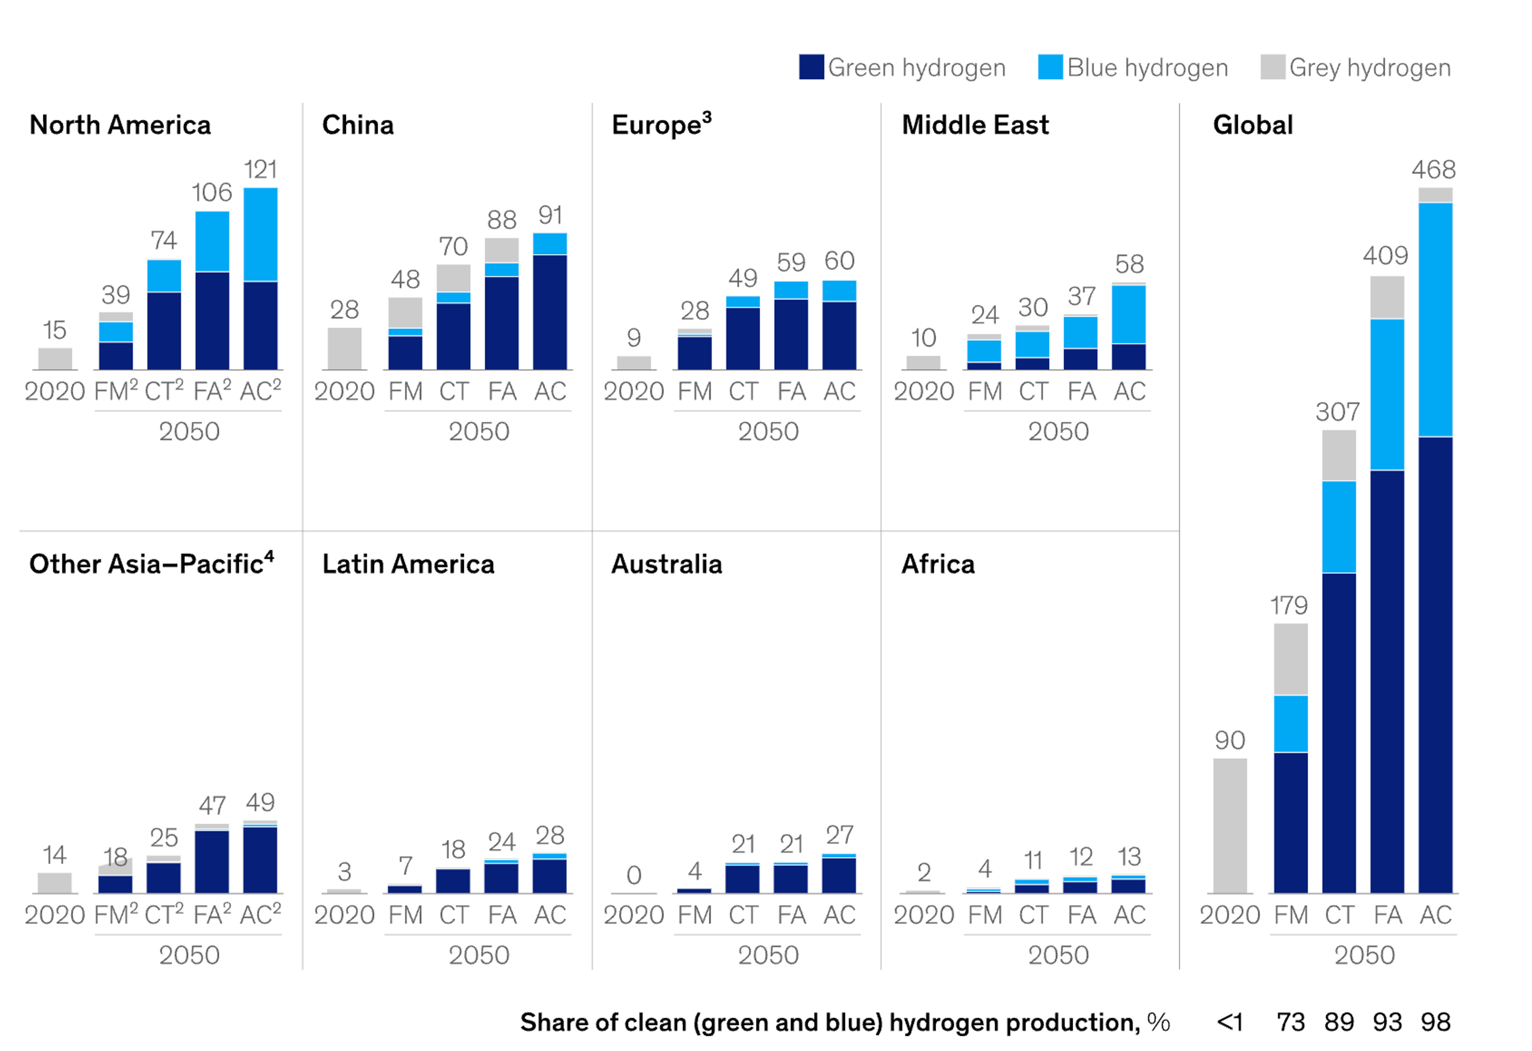
Source: McKinsey & Company, January 2024

Electric Vehicle (EV) Charging Stations

HyWatts is targeting the EV charging station market first, specifically focusing on establishing charging stations in rural areas. This strategy is designed to address infrastructure gaps in underserved regions, facilitating the adoption of EVs and supporting local economic growth. According to Precedence Research, the global EV charging station market was valued at $34.59 billion in 2023 and is projected to reach $344.61 billion by 2032, growing at a CAGR of 31.14% from 2024 to 2032.
PwC highlights that the number of EV charge points in the U.S. is expected to grow from about 4 million today to 35 million by 2030 to support an estimated 27 million EVs on the road. This rapid expansion is attributed to federal investments and incentives aimed at expanding the EV infrastructure. Additionally, the development of smart charging solutions and integration with renewable energy sources are key trends driving the market. HyWatts' focus on rural areas aligns with these trends, aiming to create a more inclusive and extensive EV charging network.

Projected EVs on the Road
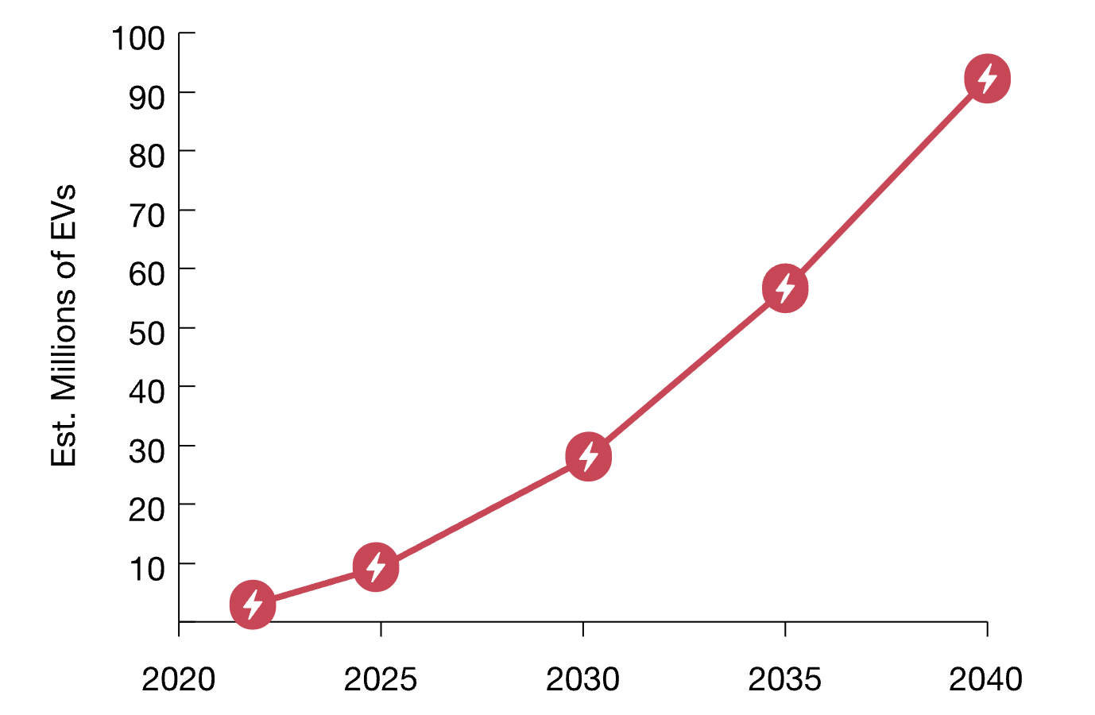
Source: PwC, 2023

Venture Financing

HyWatts competes in the broader clean technology industry, which has seen elevated venture financing activity within the last few years. From 2021 through 2023, total capital invested in clean technology companies totaled nearly $170 billion, which outpaced the previous eight years. Despite a decline in total capital invested in clean technology companies from 2021 to 2023, annual inflows remained elevated compared to 5 years ago. For instance, total capital invested has grown from $18.14 billion in 2018 to $45.87 billion in 2023, representing a compounded annual growth rate of 20.4% over this period. Additional industry insights include:
- Median deal sizes have increased within the last few years, reaching a high of $1.98 million in 2023, representing a more than 50% increase from 2021
- Clean technology companies are seeing higher valuations, as median post-money valuations have more than doubled from $7.41 million in 2019 to $17.56 million in 2023

Capital Invested and Deal Count in the Clean Technology Industry, 2013-2023

COMPETITORS


Bloom Energy (NYSE: BE): Founded in 2001, Bloom Energy is a clean energy company focused on innovative solid oxide fuel cell technology. Its primary product, the Bloom Energy Server, offers a flexible, modular platform for distributed generation, providing 24/7 reliable, resilient, and sustainable power to businesses and communities. Bloom Energy Servers convert natural gas, biogas, or hydrogen into electricity without combustion, aiming to achieve high efficiency and low emissions. Bloom Energy also produces solid oxide electrolyzers for generating clean hydrogen. Its technology supports various applications including primary power, microgrids, heat capture, carbon capture, and marine fuel cells, serving industries such as data centers, healthcare, and retail. The company’s Energy Servers have been deployed at several notable organizations including Google, Honda, Adobe, and Target, among others. Aiming to meet rising energy demands, Bloom Energy announced a partnership with data center company CoreWeave in July 2024 to develop advanced power solutions for its AI data centers. The company’s revenues grew to $1.33 billion in 2023, marking a 11.2% year-over-year increase.

Plug Power (NASDAQ: PLUG): Founded in 1997, Plug Power is developing an end-to-end green hydrogen ecosystem that includes production, storage, delivery, and energy generation, aiming to support its customers' business objectives and contribute to decarbonizing the economy. The company's electrolyzer systems utilize proton exchange membrane (PEM) technology to convert renewable electricity into green hydrogen. These systems are designed to support various applications, from small-scale to large industrial hydrogen generation. Plug Power's portfolio also includes solutions for hydrogen fueling infrastructure and fuel cell power products, aiming to facilitate the adoption of clean energy across different sectors. To date, companies such as Walmart, AT&T, Amazon, and Boeing are levering its hydrogen and fuel cell technologies. In 2023, Plug Power’s revenues grew 27% year-over-year to $891 million.

Boundary Power: Founded as a joint venture between Horizon Power and Ampcontrol, Boundary Power specializes in innovative stand-alone power systems (SAPS). A key project, HiSAPS (Hydrogen Integrated Stand-Alone Power System), showcases its advancements in integrating renewable energy sources. Funded by the Victorian Government, this project replaces traditional diesel generators with a hydrogen power system, utilizing solar power to produce hydrogen, which is then used for electricity generation. The project leverages Boundary Power’s award-winning Solar Qube®, a relocatable all-in-one system, and integrates LAVO's hydrogen storage technology, designed in collaboration with Selectronic for advanced electrical features. This system was demonstrated in October 2023 at the Ampcontrol manufacturing site in Ringwood, powering internal lighting and offering a scalable solution for remote and off-grid locations.
SunHydrogen (OTCMKTS: HYSR): Founded in 2009, SunHydrogen is a clean energy company focused on developing technology to produce renewable hydrogen using sunlight and water. The company’s primary innovation, the Photoelectrosynthetically Active Heterostructures (PAH), involves billions of microscopic nanoparticles that utilize solar energy to split water molecules into hydrogen and oxygen, creating a green hydrogen production process. Unlike conventional electrolyzers, SunHydrogen's technology does not rely on grid power or require high-purity water, making it a cost-effective and scalable solution. This approach aims to provide a sustainable alternative to fossil fuel-derived hydrogen, suitable for diverse applications including transportation and data centers. In February 2024, SunHydrogen and COTEC partnered to scale up production of green hydrogen panels, with the goal of accelerating commercialization and improving the efficiency and availability of clean energy solutions. The collaboration aims to enhance renewable hydrogen production to meet growing demand and support global sustainability efforts.


Endua: Founded in 2021, Endua is an Australian company focused on developing advanced hydrogen electrolysis technologies for on-site production of green hydrogen. Its solutions aim to produce hydrogen where and when it is needed, reducing transportation costs and environmental impacts. Endua's key products include the Endua Power Bank and the Endua Electrolyser. The Endua Power Bank is an all-in-one energy storage solution designed for decentralized industrial and commercial operations, offering a modular, drop-in approach adaptable to various applications, providing reliable on-site energy and eliminating dependence on traditional grids and fuel supply chains. The Power Bank can store energy for days to months, making it a suitable replacement for diesel generators in microgrid and standby applications. The Endua Electrolyser is a plug-and-play, power-to-gas solution for on-site hydrogen generation, featuring a compact and modular design that allows for seamless integration into new and existing sites without extensive upgrades, ensuring peace of mind regarding hydrogen supply chains and mitigating the challenges associated with transportation and bulk storage of hydrogen. In May 2023, Endua raised $7.5 million in pre-series private funding from Queensland Investment Corporation (QIC), Melt Ventures, and 77 Partners.

EXECUTIVE TEAM


Alex Ivanenko PhD, Co-Founder and Chief Executive Officer: Alex Ivanenko co-founded HyWatts in 2023 and serves as its Chief Executive Officer (CEO). Prior to HyWatts, Alex founded and served as CEO of HyPoint for over five years, a Silicon Valley-based manufacturer of next-generation hydrogen fuel cell systems. In October 2022, HyPoint was acquired by hydrogen-electric aircraft manufacturer ZeroAvia for $80 million. Before HyPoint, he was a Sales Leader, Commonwealth of Independent States (CIS) and Russia, at 3M for over three years. Additionally, he held the position of Area Sales Manager for Russia and CIS at Owens Corning for five years. Alex has also been a member of Alchemist Accelerator (Class 24) since 2019. He holds a Master’s of Business Administration (MBA) in Business Administration and Management from The Russian Presidential Academy of National Economy and Public Administration (RANEPA), a Doctor of Philosophy (PhD) in Electrochemistry, and an Engineering degree from Saratov State Technical University.


Dietmar Trees, PhD, Co-Founder and Chief Technology Officer: Dietmar Trees helped found HyWatts in 2023 and currently serves as its Chief Technology Officer. Prior to this, Dietmar was the Head of Innovation and Program Management for the Rotorcraft Division at ZeroAvia for just over a year. He also served as the Head of Program Management at HyPoint for over a year. Before joining HyPoint, Dietmar spent over six years at semiconductor company ASML, where he held roles as Project Manager and Team Lead Supply Chain Engineering. His earlier career includes positions at Pratt & Whitney as Program Chief Engineer and Project Manager, and at United Technologies, where he served in various roles including Director of Supply Chain Management and Program Manager over an eight-year span. Dietmar holds an MBA in Business Administration from UC Irvine as well as a Doctor of Science and PhD in Engineering from RWTH Aachen University. Additionally, he has authored 11 publications and holds 16 patents.


Sam Ruben, Co-Founder and Chief Business Development Officer: Sam Ruben founded HyWatts alongside Alex and Dietmar in 2023 and serves as Chief Business Development Officer. Sam is also a Core Member of the G20 Sustainability Taskforce at the World Economic Forum, a position he has held since January 2023. Prior to his current roles, Sam co-founded Mighty Buildings, where he served as Chief Sustainability Officer for nearly five years before shifting into the role of Senior Sustainability Advisor in April 2022. He also co-founded and has served as a Senior Sustainability Advisor at BuildTech VC since October 2021. Additionally, Sam is an Advisor at ADL Ventures and an angel investor in multiple companies including RainStick, Swyft Cities, Zauben, Rise, and FieldNav. Earlier in his career, he held roles such as Teaching Assistant (TA) for Sustainable Operations and Production at Presidio Graduate School, Sustainability Coach at REV: Accelerate Sustainability, and Associate Consultant at Friday Consulting SF. Sam began his career with various roles at organizations including the City of Berkeley, EDF Climate Corps, United Religions Initiative, and CBS Radio. He holds an MBA/Master of Public Administration (MPA) in Sustainability Management from Presidio Graduate School and a Bachelor of Arts in Political Science/Economics from Vassar College.

SOURCES

https://fuelcellsworks.com/news/department-of-energy-announces-52-million-for-small-business-research-and-development-grants-including-3-4-million-for-hydrogen-and-fuel-cell-projects/
https://www.mckinsey.com/industries/oil-and-gas/our-insights/global-energy-perspective-2023-power-outlook
https://www.clearias.com/world-energy-outlook/
https://www.goldmansachs.com/intelligence/pages/AI-poised-to-drive-160-increase-in-power-demand.html
https://www.plugpower.com/the-rise-of-green-hydrogen-stats-trends-and-future-projections/
https://www.goldmansachs.com/intelligence/pages/AI-poised-to-drive-160-increase-in-power-demand.html
https://www.iea.org/reports/global-ev-outlook-2024/outlook-for-battery-and-energy-demand
https://www.tdworld.com/distributed-energy-resources/article/55019330/the-macro-impact-of-the-microgrid
https://www.biologic.net/topics/what-are-pem-fuel-cells-and-electrolyzers/
https://www.biologic.net/topics/what-are-pem-fuel-cells-and-electrolyzers/
https://fuelcellsworks.com/news/department-of-energy-announces-52-million-for-small-business-research-and-development-grants-including-3-4-million-for-hydrogen-and-fuel-cell-projects/
https://www.grandviewresearch.com/industry-analysis/renewable-energy-market
https://www2.deloitte.com/us/en/insights/industry/renewable-energy/renewable-energy-industry-outlook.html
https://www.iberdrola.com/about-us/what-we-do/green-hydrogen/difference-hydrogen-green-blue
https://www.marketsandmarkets.com/Market-Reports/green-hydrogen-market-92444177.html
https://www.marketsandmarkets.com/Market-Reports/hydrogen-energy-storage-market-107179995.html
https://www.mckinsey.com/industries/oil-and-gas/our-insights/global-energy-perspective-2023-hydrogen-outlook
https://www.precedenceresearch.com/electric-vehicle-charging-station-market
https://www.pwc.com/us/en/industries/industrial-products/library/electric-vehicle-charging-market-growth.html
https://www.bloomenergy.com/customers/
https://www.businesswire.com/news/home/20240716719982/en/Bloom-Energy-and-CoreWeave-Partner-to-Revolutionize-AI-Data-Center-Power-Solutions
https://investor.bloomenergy.com/press-releases/press-release-details/2024/Bloom-Energy-Reports-Fourth-Quarter-and-Full-Year-2023-Financial-Results-with-Record-Full-Year-Revenues/default.aspx
https://www.plugpower.com/about-us/customers/
https://www.theglobeandmail.com/investing/markets/markets-news/Motley Fool/27447869/why-plug-power-plummeted-48-in-the-first-half-of-2024/
https://www.pv-magazine.com/2023/10/16/australian-startup-develops-pv-hydrogen-standalone-power-system/
https://www.hydrogen-expo.com/industry-news/partnership-between-cotec-sunhydrogen-see-scale-up-green-hydrogen-panels
https://www.aumanufacturing.com.au/hydrogen-energy-company-endua-raises-11-8-million
https://www.researchgate.net/scientific-contributions/D-Trees-2002432383
https://patents.google.com/?inventor=Dietmar+Trees&oq=Dietmar+Trees

